UML Diagrams

Use Case Diagram
A Use Case Diagram is a visual representation of the functional requirements of a system, highlighting the interactions between actors (users or external systems) and the system itself. It captures what tasks the system can perform, who can perform them, and how the system responds to different user actions (Sommerville, 2016). In the AI-Powered Crop Disease Detection and Recommendation System, the use case diagram demonstrates the dynamic interactions between farmers, administrators, agricultural experts, and the AI system. Farmers can submit images of crops to detect diseases, receive automated treatment recommendations, and track the health of their crops over time. Experts can validate disease diagnoses and update treatment suggestions. Administrators manage user accounts, monitor system performance, and ensure data integrity. The AI system acts as a central processing entity, analyzing submitted crop images, detecting diseases using machine learning models, and generating relevant recommendations for treatment. This use case representation helps stakeholders understand the system’s functional capabilities, clarifies user roles, and serves as a foundation for system design and development (Jacobson et al., 1992).

Notation used in use case

- Actor
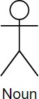
Actors give the various kinds of users/external systems expected to communicate with the system. They may be individuals, other applications or computer hardware that interact with the system to get things done. The system presents certain roles to different actors and each communicates with the other to reach a goal. Actors in a use case diagram are usually depicted as a stick figure outside the system boundary. As an example, a customer, administrators, and sellers are the actors likely to appear in an e-commerce system. The naming convention is noun.

- Use Case
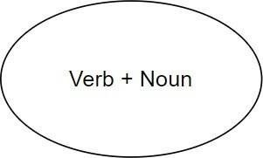
Figure 4: Notation for Use Case
Describing how the system responds to actor requests, use cases detailed the actual actions/tasks performed by the system in response to such requests. Every use case symbolizes a functional requirement, or a specific service that the system provides to the persons. Within the system bound, use cases are shown as horizontal ovals (or ellipses) with the name of the functionality written in them. As an example, use cases could consist of the following in the same context of the e-commerce example: such as Register Account, Place Order, Manage Products, and Generate Sales Report. These assist in explaining what the system should perform on the part of the users.

- System boundary

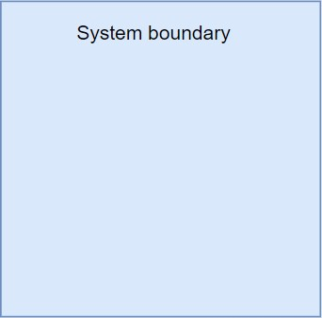
Figure 5: Notation for System boundary
The system boundary controls what is within a system and excludes actors outside a system. It is signified by a great rectangle (box) that contains all the use cases and depicting what belongs to the system or what is outside of it. This is because usually the name of the system is written in the top part of the rectangle. The presented visual representation assists the stakeholders to make a clear distinction between internally defined behaviors and externally defined behaviors and thus have a well-scoped system design.

- Association

Figure 6: Notation for Association
An association is shown by a solid straight line between an actor and a use case. It means that the actor is involved in the use case, either as a producer of the call that leads to use case or as a consumer of some results of the use case. It is in most cases that they do not have an arrowhead as their lines unless the direction is required to be indicated. The use case diagram depends on associations to resemble its foundation based on the direct interaction of the system and the user (or external element).

- Include

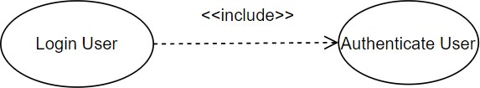
Figure 7: Notation for Include
The include relationship is represented by a dashed arrow labelled «include» and whose direction is drawn as showing the base use case to the included use case. It refers to the fact that the behavior of the included use case will be always executed when executing the base use case. This prevents duplication as it is possible to share functions. In diagrams, the arrow is extended towards the inclusion use case and indicates that such an inclusion is mandatory.

- Extends
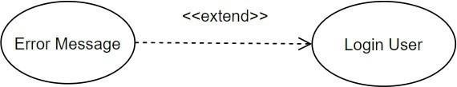
Figure 8: Notation for Extends

The extend association is also illustrated using a dashed arrow but the direction is in opposite as labelling whereby the label is extended and the extended use case points at the base use case. It describes optional or contingent behavior, which can be activated, only under some conditions. It means that the base use case can remain short and extensions can be addressed individually. The direction of the arrow, against which optional functionality, directs to the major covering use case.

- Generalization

Figure 9: Notation for Generalization
Generalization is shown as a solid line having a hollow triangle arrow at the end with the more specific actor or use case on the tip. To actors, this implies that all the roles and responsibilities of the parent actor are transferred to the child actor. To be used, it indicates that the specialized use case is the special form of the generalized one. The visual provides reuse of actors/behaviors and hierarchy of actors/behaviors

Actor and Use Case
1. Actors:
- Farmer
- Admin
- Expert
- AI System

- Use Cases:
- Farmer:
- Register
- Login
- Upload Crop Image
- View Disease Detection Result
- View Confidence Score
- View Treatment Recommendations
- View Prediction History
- Receive Disease Notifications
- Participate in Discussion Forum

- Admin
- Manage Users
- Manage Crop Disease Dataset
- Retrain AI Model
- View Analytics Reports

- Expert
- View Farmer Queries
- Reply to Farmer Queries

- AI System
- Preprocess Image
- Detect Crop Disease
- Store Prediction History
- Generate Analytics
- Send Notifications

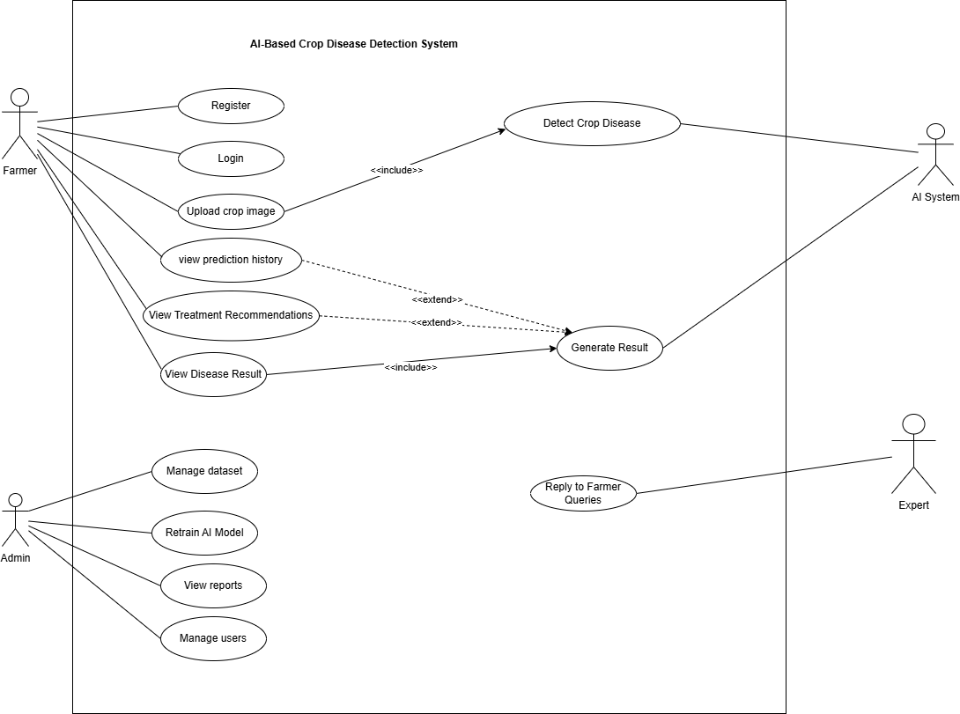
Figure 1: Usecase diagram

Aligned User Stories:
US001, US002, US003, US006, US007, US008, US011, US012, US015, US016, US017, US022, US023, US024
This use case diagram illustrates the interaction between farmers, administrators, experts, and the AI system. It highlights the functional requirements of the system, including disease detection, treatment recommendation, dataset management, and expert interaction.

Activity Diagram
An Activity Diagram is a behavioral diagram in UML that represents the workflow of activities within a system. It shows the step-by-step progression of control from the initiation of a process to its completion, illustrating the sequence of actions, decision points, parallel activities, and synchronization between different tasks (Booch et al., 2005). Activity diagrams are particularly effective for modeling business processes, system workflows, and use case realizations, as they visually clarify how various activities are executed in response to specific events. They provide stakeholders with a clear understanding of the dynamic behavior of the system by illustrating how actions are coordinated and how control transitions between them.
In the AI-Based Crop Disease Detection and Recommendation System, an activity diagram models the workflow beginning with image upload by the farmer, followed by image preprocessing, disease detection using the AI model, result generation, and finally the display of treatment recommendations. By representing these steps, the activity diagram helps ensure a clear understanding of system operations, supports effective system design, and enables validation of the processes, thereby enhancing both usability and reliability of the system (Ambler, 2004).
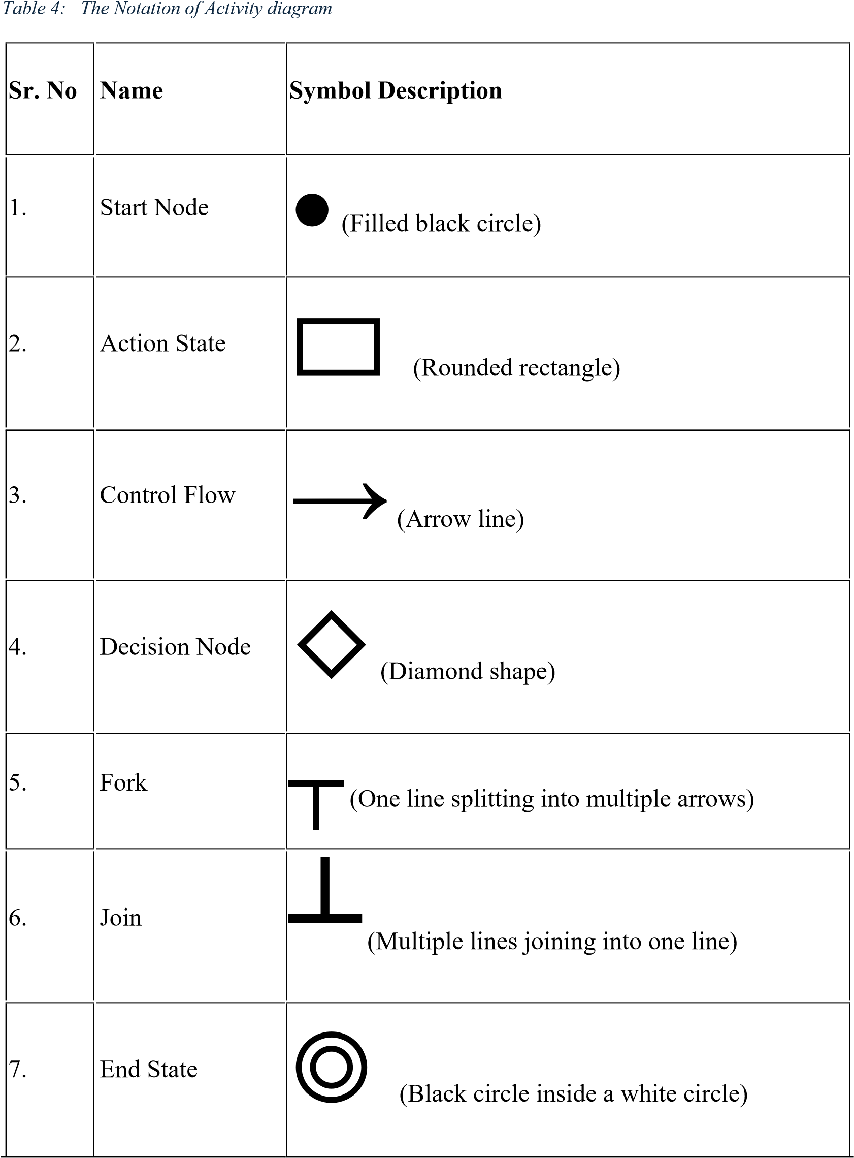

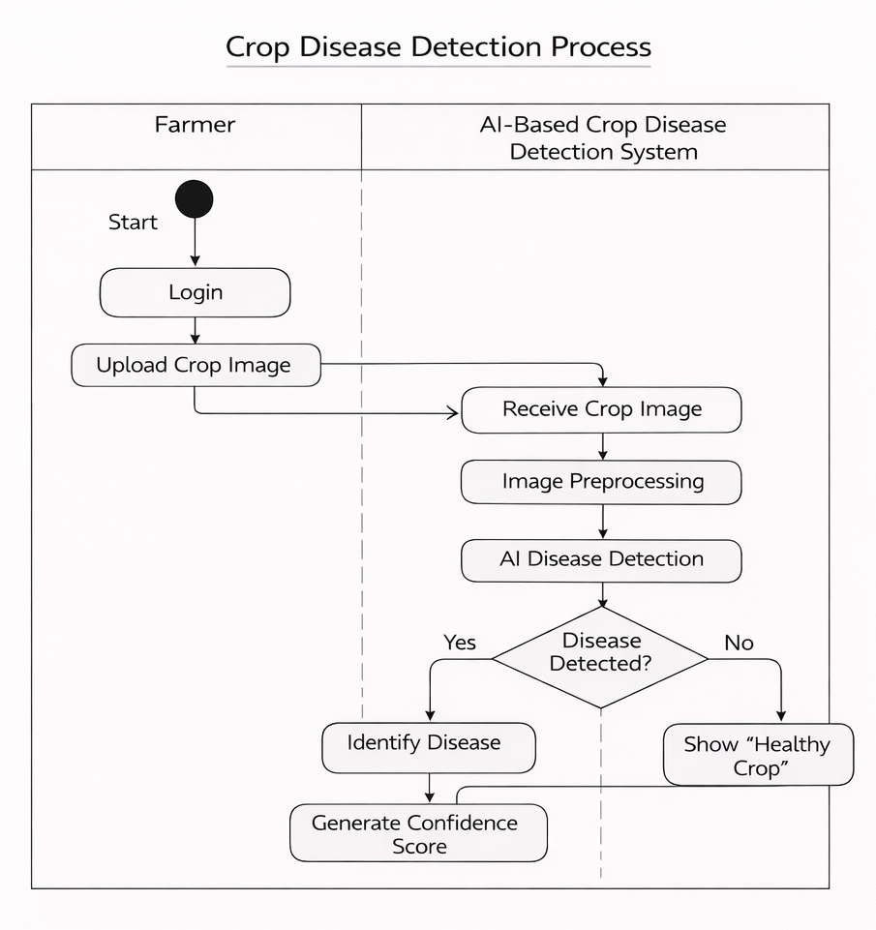

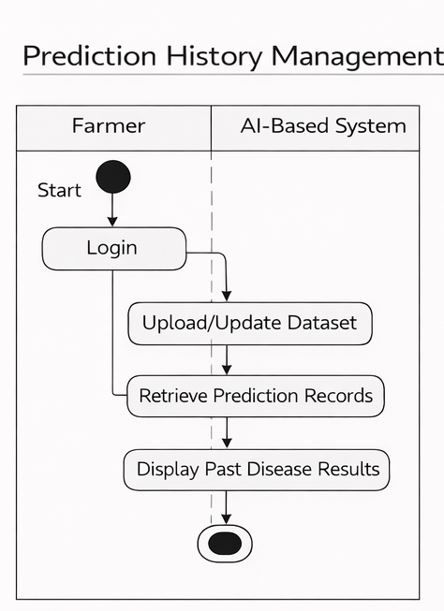

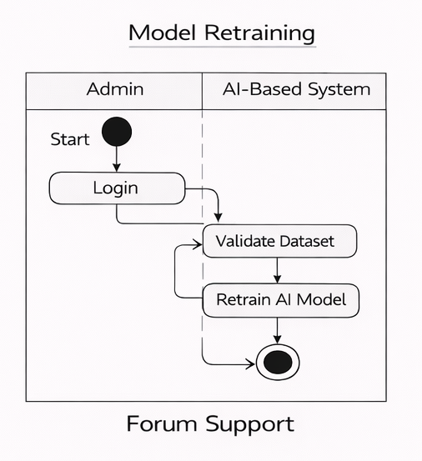

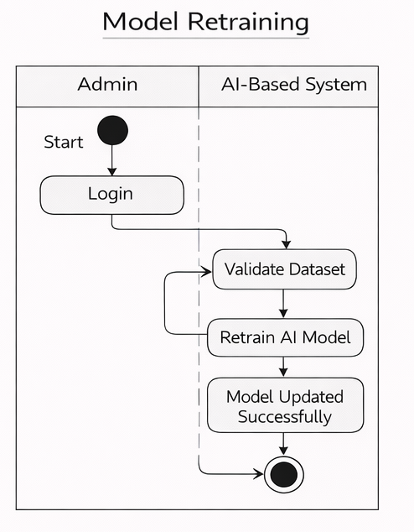


Aligned User Stories:
US003, US004, US005, US006, US007, US008, US011

Sequence Diagram
A Sequence Diagram is a type of UML interaction diagram that illustrates how objects or system components interact with each other over time. It focuses on the order of messages exchanged between different entities to accomplish a specific functionality or use case. The diagram presents participants as lifelines arranged horizontally, while messages are shown as arrows that indicate the direction and sequence of communication from top to bottom, representing the flow of time (Booch et al., 2005).
Sequence diagrams are particularly useful for modeling dynamic behavior, validating system logic, and understanding how responsibilities are distributed among system components. They help developers and stakeholders visualize system processes, identify dependencies, and ensure that interactions occur in the correct order. By clearly depicting method calls, responses, and control flow, sequence diagrams support effective system design and improve communication among development teams (Sommerville, 2016).
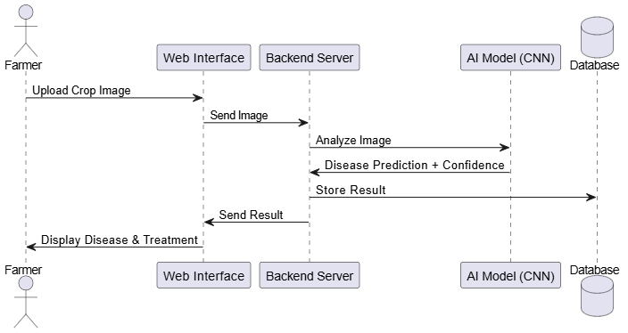

References
- Sommerville, I., 2016. Software Engineering. 10th ed. Boston: Pearson.
- Jacobson, I., Christerson, M., Jonsson, P. and Overgaard, G., 1992. Object-Oriented Software Engineering: A Use Case Driven Approach. London: Addison-Wesley.
- Booch, G., Rumbaugh, J. and Jacobson, I., 2005. The Unified Modeling Language User Guide. 2nd ed. Boston: Addison-Wesley.
- Ambler, S.W., 2004. The Object Primer: Agile Model-Driven Development with UML 2. 3rd ed. Cambridge: Cambridge University Press.
- Booch, G., Rumbaugh, J. and Jacobson, I., 2005. The Unified Modeling Language User Guide. 2nd ed. Boston: Addison-Wesley.
- Sommerville, I., 2016. Software Engineering. 10th ed. Harlow: Pearson Education Limited.

